Namus: The Corporate Family Identity of the Arab Family Business

Georgios Palaiologos
Social, Cultural and Religious Embedding of Family Businesses, University Witten-Herdecke, Germany
gpaleol@yahoo.com*

Tobias Köllner
Department of Management and Entrepreneurship, Faculty of Business and Society, University of Witten/Herdecke, Germany
tobias.koellner@uni-wh.de

Nehal El-Naggar
College of Business & Law, Royal University for Women, Bahrain
nelnaggar@ruw.edu.bh

Abstract
Introduction/Main Objectives: The study examines the distinctive and intriguing cultural context of Arab Family Businesses (AFBs) and the development of Corporate Family Identity (CFI) under the influence of Namus. This cultural concept embodies honor, reputation, and moral integrity. The research aims to unravel how Namus shapes the creation and perpetuation of corporate identity in AFBs, a fascinating and rich cultural context. It underscores how cultural norms, specific to the Arab context, influence family branding and corporate identity management. Research Methods: The research employs an idiographic case study technique, focusing on two theoretically selected case studies to provide integrated and nuanced knowledge. Using a modeling-as-theorizing approach, we also employ interpretivism with latent content analysis, a legitimate theory-building instrument in the development of a middle-range theory (Namus - Construct of Family Corporate Identity). This unique approach enables us to explore the impact of Namus on Corporate Family Identity in Arab Family Businesses. Finding/Results: The findings suggest that Namus is a fundamental theoretical construct that guides corporate identity, honor, and emotional conceptions in Arab family businesses, with notable implications for both theory and practice. Our research reveals that Arabian cultural concepts, such as ‘Ird, Sharaf, Karamah, Sumea, Mojamala, Hamula, and Nasab, play a substantial and appreciable role in shaping the corporate identity of business families. Specifically, the discussion focuses on how these cultural concepts influence familial identity, organizational culture, and branding decisions. Conclusion: The analysis identifies several ways in which Namus shapes business operations in the Decision-Making Processes (Ethical considerations, Family reputation, Long-term sustainability), Organizational Culture (ethical behavior, employee conduct, and cultural traditions), and finally, Market Positioning (Cultural authenticity, family reputation). The significance of this investigation lies in its potential to bridge the gap in the literature concerning the interplay between familial identity and corporate practice, as well as qualitative/mixed inquiries in the Arab context. By shedding light on Namus's influence on Corporate Family Identity, we contribute to a deeper understanding of cultural influences in Arab family businesses.

Keywords: Namus, Corporate Family Identity, Arab Family Businesses, Organizational Culture, Familial Identity

1. Introduction
Family enterprises, the essential building blocks of our global economy, have long been associated with many unwritten conventions. The activities of the Arab business community combine economic efforts and the reflection of family honor, social norms, and history (Rice et al., 2024; Samara, 2021; Purfield et al., 2018; Farouk et al., 2017). The establishment of personal and business relationships and reputations is governed by the ancient concept of Namus, an abstract word that defines family honor and integrity (Al-Ghamdi, 2018; Meeker, 1976; Cetinkaya, 2024). The Arab world, a crossroads of humanity and a region with deep ancient roots, a people with wisdom, and a multitude of established traditions, is distinguished by the emergence and development of individuality. A family business is a significant business form found in almost all nations. Business is shaped by culture, where traditional values and present practices interplay. Namus plays a significant role in Arab culture (Mudin, 2024).
Arab family businesses are distinct from Western family businesses, with a substantial impact on the local economy. They are steeped in social and cultural values and influenced by Namus in defining family governance principles, business ethics, and leadership style (El-Sayed & Craig, 2017; Abbasi & Hollman, 2020). Therefore, the study of Namus and the values that are closely related to it, is an important way to understand the special character of business in the Arab world. Kanoo (2011), one of the founding members of the Bahrain Family Business Association (BFBA), estimates that approximately 95% of all businesses in Bahrain are family owned. Kanoo believes that the primary difference between Bahraini family companies and other family businesses worldwide is the unity of the family. The family is so important that it maintains a link of respect between the founder of the firm and other family members. In addition, history and culture have a huge impact on Bahraini family companies (Basco, 2017; Basli, 2017; Darwish, 2020).
With family business, relationships between members and the corporation are enhanced because it is directly connected to their families, which leads to more personal-organizational contact in forming corporate identity (Alshibani and Aljarodi, 2024; Kollner, 2022). Our study has value since it may address the gap in the literature regarding the relationship between familial honor and corporate practice within a competitive Arab business setting. The economies of the Middle Eastern countries have had a history of family firms that have significantly contributed to the growth of the economy. Nevertheless, even with the recent efforts to advance the area of research on the topic, the gap in the studies on family businesses in the Middle East is apparent (Basco, 2017; Farah et al., 2021). The lack of such studies in the literature justifies the significance of our study. Also, there are not many studies that pay attention to specific contextual research. To resolve the situation of a context-less gap in the family business research, we dwell on the Arab world as a case of a successful implementation (Krueger et al., 2021; Adjei et al., 2025). A study that gathers the perceptions of semantic scholars proposes that the proposed future research in the field of family business needs to be theoretical (Christman), business family (Sciascia), and special paradoxes and approaches (Discua Cruz). However, regardless of the progress achieved in the field of understanding corporate identity in family businesses, there are various gaps, which speaks of the necessity to conduct more studies in that field and in the region in particular: It is easy to believe that Namus has a hidden hand and is an innate cultural driver. More primary data that specifically looks into the role of familial identity, honor, and reputation in normal operational practices and strategic decision-making is required. Such a limitation exists in comparative research in most areas and industries, which compromises the extrapolation of current results. This research will fill the gap that exists in the literature on family companies in the Middle East, especially the role that the Arabian culture has on such companies. The distinctive cultural setting of Middle East and specially Bahrain contributes to the depth and uniqueness of our exploration. A cultural background of the Middle East also contributes to a certain level of enrichment and specifics to our exploration. As such, the study will focus on how one of the most significant cultural aspects in the Middle East, Namus, influences the formation of corporate family identity comprehension of AFB in the Kingdom of Bahrain. We shall discuss how the reputation of family members and family honor issues in the Middle East culture can influence the corporate identity and branding of a family business. In this context the research questions that will be dealt with in this paper are as follows: What is the role of Namus in telling the construction and the maintenance of corporate identity within family enterprises? How does the culture impact on the practice of branding and corporate communication? What is the contribution of the cultural, social, and family notions like Sharaf, ‘‘Ird, Karamah, Mojamala, Sumea, Nasab and Hamula to the CFI?.

2. Literature review

2.1 Family business in the Arab World
Family enterprises represent the most prevalent business model worldwide, functioning as the primary source of new job creation. Studies consistently demonstrate that the financial performance of family-owned enterprises significantly exceeds that of non-family organizations, especially when a family member holds the position of CEO (Rautiainen, 2019; Krueger et al., 2021; Ratten et al., 2024; Palaiologos & Köllner, 2025).
Tagiuri and Davis (1996) describe a family business as an organization where two or more extended family members impact the business's direction through kinship links, managerial responsibilities, or ownership rights. Zellweger et al. (2012) state that portraying the firm as a family enterprise enhances its performance by recruiting clients and increasing sales. It occurs due to the distinctive characteristics of family firms, including pride in the family business, a long-term perspective, and social connections within the community (Zellweger et al., 2010). Chua et al. (1999) suggest the relevant definition:
"The family business is a business governed and/or managed with the intention of shaping and pursuing the vision of the business held by a dominant coalition controlled by members of the same family or a small number of families in a manner that is potentially sustainable across generations of the family or families."
Later, Ratten (2023) proposed a more nuanced definition that incorporates emotional and kinship dimensions.
“A family can be defined in general terms as a group of people (more than one person) with a strong emotional connection. This implies a sense of solidarity among people that differs from the relationships that occur in friendships or work situations. Therefore, the word family refers to a longer-term connection between those involved in the relationship. It is built on trust and mutual interdependencies. Thus, a family business can be distinguished from a non-family business by the relationships among the people involved. This means a family business is built around a unique connection of emotional connections, trust, and interdependence. The degree of this connection can occur through strong or weak ties, depending on the business structure. What is important is that all family members can be identified through these connections.”

2.2 Arab Family Business
Palaiologos (2017) asserts that the concept of Arab family businesses differs considerably from family businesses worldwide. He identifies four key constructs that uniquely define family businesses in the Arab world: The Diwan, a repository of accumulated knowledge and family business governance; the Wasta, a network of influence within society; the Namus, the family's identity and values that must be preserved; and Asabiyyah, the social imaginary and solidarity of AFB. These unique constructs not only differentiate Arab family businesses but also form the foundation of AFB theory, making it a fascinating area of study.
To better examine the AFB phenomenon, Palaiologos (2017) proposed a definition that applies to the Arab context. This definition's main contribution is to differentiate it from the three-circle model of family, business, and ownership (Tagiuri & Davis, 1996), and to set the cultural context in which it operates. Additionally, the definition provides conceptual clarity and inclusiveness.
Arab Family Business is the nexus of kin-based relationships and entrepreneurial images or networks. The raison d'être is to create value for the family embedded in the social context, preserve family loyalty, spread the sense of belongingness to all, and enhance the family image in the social setting. The value could be monetary, non-monetary, or both. Its governance is communicated within the traditional setting of the Diwan; senior people enact decisions, but all share ownership of them, and knowledge is implicitly transferred horizontally and vertically across generations. The structure of the Arab family business is shaped by the hierarchical traditions of Diwan and the influence of Wasta (Networks) and Asabiyyah (Social Solidarity). Family members must contribute to the added value of the family name (Namus) and the unique family identity (Palaiologos, 2017).

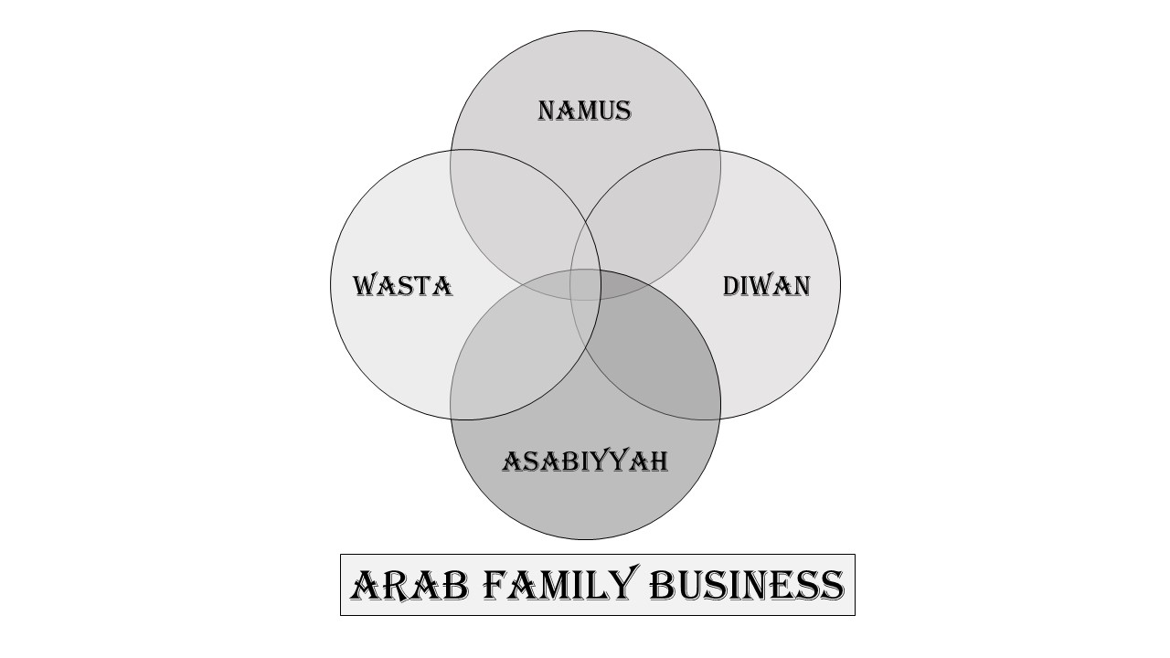
Figure 1. Arab Family Business Framework (Palaiologos, 2017)

2.3 Namus - Corporate Family Identity (CFI) and Brand Identification
Corporate identity is the manifestation of an organization to the rest of the world and is the way of how an organization shows itself. The family businesses are highly characterized by their unique nature that is often based on their family background and family traditions (Blomback, 2009; Craig et al., 2008). The name of the family as a branding tool may be a good way of communicating reliability and generational continuity. Organizations create an image of themselves using graphics and narration that appeal to the stakeholders. A family name, when applied strategically, is a highly valuable brand strategy showing success and well-established reputation, and incorporating family values into the business usually enhances customer loyalty and builds greater trust (Radu-Lefebvre et al., 2024; Krappe et al, 2024).
Corporate and personal identities are connected although they are different. Corporate identity incorporates what belongs to members of their organization and its features and includes principles, vision, and branding (Tsai, 2008; Balmer, 2017).
Family business is a special combination of identities, whereby there is an amalgamation of the aspects of a family and a business organization (Whetten et al., 2014, p. 481). The relationship between the members and the organization is an important aspect especially in family firms because it helps to determine the company attributes that are most appealing to the people. Once people are able to relate to the several business processes, including the family affiliations and the corporate purpose, they are more likely to display higher loyalty, elevated job satisfaction, and deeper commitment, in particular, in business family settings (Whetten et al., 2014, p. 491).In Arab family enterprises, identity is tied to the founders' beliefs and cultural heritage, emphasizing trust, loyalty, and group accountability (Gersick et al., 1997; Bettinelli et al., 2022). Corporate branding manages brand communication and brand identity, which reflect commitments of trust and consistency (Craig et al., 2008; Blombäck, 2009; Zellweger et al., 2010). A company's brand consciously communicates its organizational character to important audiences and represents one of its most valuable invisible assets (Balmer, 2001; Krappe et al., 2011). When a brand is associated with family, it significantly influences how family members conduct themselves, as their behavior directly impacts the family's standing and reputation (Craig et al., 2008). Corporate Family Identity (CFI) is a term that describes a sense of belonging and shared values within a company, a concept particularly relevant in the Arab world, where kinship and family values are strong (Kabbach, 2011; Zahra, 2005). CFI is deeply connected to family history and relationships in these enterprises, shaping strategic decisions and stakeholder perceptions in a way that is uniquely different from non-family firms (Al-Alawi & Fermanis, 2014; Ramadani et al., 2015). The interplay between CFI and external stakeholders in the Arab world is vital. Family reputation often mirrors business reputation, encouraging ethical behavior (Dutton & Dukerich, 1991) and community engagement (Jamali et al, 2010). However, familial issues can harm the business's reputation (Bromley, 2001). Arab family businesses that expand internationally struggle to preserve their core family identity while embracing global business approaches (Khanna & Palepu, 2010). Within Arab business culture, traditional values such as Namus substantially affect companies' operations (Palaiologos, 2017; Cetinkaya, 2024). This concept of Namus—encompassing personal honor, ethical standards, and community responsibilities—guides individual and family behavior, shapes relationships with stakeholders, and establishes ethical boundaries in business dealings. It strongly emphasizes familial affiliation, honor, and ethical duty, safeguarding heritage and societal esteem (Al-Khatib et al., 2016). Namus influences ethical practices, leadership, and gender roles, and is a key element of Arab family businesses (Al-Serhan, 2010).
Namus which is a Greek equivalent of nomos (law/custom) refers to actions of an elevated level of morality and is commonly associated with sexual honor. It connects Namus to ‘‘Ird ( personal or small unit honor) and Sharaf ( larger family honor). Sharaf, commonly referred as ‘‘Ird, is honor as a result of a good reputation in the society, obtained through the process of living by the values and being modest (Palaiologos, 2017; Dodd, 1973; Meeker, 1976).
The Arab family businesses have a unique cultural values which are deep-rooted in the business and thus influence their corporate identity. These values go much further than mere branding or image recognition, but they affect the very perception of these companies and the way they carry business. Some major values are ‘‘Ird (personal honor or saving face), Sharaf (family honor and integrity), Karamah (dignity and respect), Mojamala (emotional intelligence and reciprocity), Sumea (reputation and goodwill), Hamula (extended family ties), and Nasab (family lineage). These subtle aspects of culture are important in understanding the identity factors of family businesses in the area where individual status and family reputation can oftentimes be the key to business success.

2.4 The Arab Cultural Concepts
‘‘Ird is the term which is sometimes referred to as honor or reputation and it is the focus of Arab social and commercial life (Abu-Lughod, 1986; Dwyer, 1978; Steward, 1994, p. 64). The activity of each of the family members can have positive or negative impacts on the entire group. Family business is required to have a powerful ''‘‘Ird. It guarantees ethical conduct, quality of products and services and equity to the stakeholders. Another type of violation in companies or by a family member may harm the ‘‘Ird, damaging the consumer confidence, supplier relationship, and business sustainability (Cunningham and Sarayrah, 1993). Therefore, the self-regulating of corporate activities and maintaining ethical conduct are under the jurisdiction of the pursuit and protection of ‘‘Ird (Kuran, 2004). Stewart (1994, p. It is the difference between personal honor (horizontal relationships) and group honor (vertical relationships) that 30) draws. Nobility, integrity, and moral status are considered as one of aristocratic qualities, Sharaf, which supports the ethical aspects of family firms (Al-Munajjed, 2000). This notion means honesty and morality in business transaction. Family businesses with Sharaf build a reputation of integrity and trustworthiness. This credibility of honesty may be a substantial competitive advantage in the context of business activities where trust and personal relationships are paramount (Fukuyama, 1995; Faraj, 2022, p. 19). Sharaf tends to use the family history and tradition to lead the company (Hosmer, 1995).
Karamah is also associated with '‘‘Ird such as dignity and respect (Goffman, 1967). It lays stress on the value and dignity of people, families, and companies. Karamah needs to respect the consumers, employees, and business partners. This is indicated by politeness, fairness and respect. Companies acting in compliance with Karamah receive the respect and loyalty of the community and social status (Schneider, 2017). On the other hand, uncivil or disrespectful actions may harm the Karamah and company of the family and result in the social ostracism and business losses (Thompson, 2010).
Mojamala- social graces, emotional connaissance, reciprocity is crucial in business (Bourdieu, 1977). There are hospitality, politeness in social interactions and favors. Effective Arab business transactions and partnerships occasionally require close personal connections by Mojamala (Berger et al, 2015). The family businesses, with a solid foundation on their social networks, are often good at establishing trust and goodwill. It is also ill-mannered to ignore Mojamala, and it will block the way to commercial relationships (Weir et al, 2019; Vellez-Calle et al, 2015).
The terms Sumea (meaning reputation, fame, and goodwill) is the positive image of a family and a business, obtained by an ethical approach, high quality products, and good position in society. The family is perceived as honest and trustworthy by stakeholders, namely customers, suppliers, workers, and community. Sumea is an extensive component of the family social capital, which was nurtured across generations (Youseif and Abuamsha, 2019). It establishes customer confidence, draws talents and creates commercial relationships within the Arab business society (Hassan & Khalifa, 2021). It takes ethical conduct, quality products as well as community involvement to maintain a good Sumea.
The Hamula or extended family or kinship group is a great necessity in the Arab society and it influences family enterprises (Lancaster, 1997). The Hamula is usually giving family business support, capital, and workforce. The needs and interests of Hamula can also impact the business decisions and family members usually occupy the important positions. The Hamula family will improve its reputation as a result of success in the business (Patai, 1983). It can also be that nepotism and conflict between personal and economic interests are brought about by Hamula influence (Redding, 2005).
Nasab or lineage and heritage symbolizes family values and traditions (Al-Jafari and Perry, 2011; Metcalfe, 2007). Nasab establishes ethical and cultural requirements of family business and decision making. Elementary to Nasab and family businesses are family respect (''‘Ird), deference among the elders, and traditional values (Jamal & Al-Khatib, 2003). Arab communities are interweaving. Consequently, this acquired value system usually translates into a long term dream, a commitment to excellence founded on family pride and a greater social responsibility to the society (Sidani and Thornberry, 2013). Therefore, Nasab directs the culture and relations of the company.
The corporate family identity of AFBs is a compounding of ‘Ird, Karamah, Sharaf, Mojamala, Sumea, Hamula and Nasab. These cultural norms influence the company ethics, relations with stakeholders, and reputation. These aspects can create the trust, loyalty and sustainability, yet the family companies have to address the issues of preserving the values during the high rates of globalization and modernization. These related aspects should be comprehended and strategically addressed to make family companies successful and reputable in the Arab region (Rice et al, 2024; Weir et al, 2019).

3. Research Method
The article uses a mixed-method to analyse the impact of Namus on the identity of the family companies, specifically considering the cases, and discussing their perceptions. It interprets those statements of the company, interviews with leaders, and corporate reports, basing on the information provided on their websites, on the documents and archives of the company. Mixed methods research is an approach that provides a method and methodology, which is characterized as a collection, analysis, and integration of qualitative and quantitative approaches in one study or a series of studies (Creswell and Plano Clark, 2011). Mixed methods bring about improved explanations of social settings because of the context and also pursuing what can be called dialogic explanations, which relies upon qualitative, constructivist knowledge. (Creswell et al., 2006).
An idiographic case study is a qualitative research method that is used to study an individual in its entirety, a group, an event, or situation (Yin, 2018). This holistic method provides an in-depth insight into the particular instead of establishing generic principles (Flyvbjerg, 2006). Latent content analysis involves the researcher to interpret the data and create the meaning that is not explicitly conveyed but hides between lines, or represents some symbolism (Hsieh and Shannon, 2005).
Ontological bases of this methodological combination tend to lean towards interpretivism or constructivism. These perspectives state that reality is non-objective and non-unitary since it is a product of society and is subjectively seen by individuals (Berger and Luckmann, 1966; Creswell and Creswell, 2017). This means that to understand an individual case; one has to understand their subjective world and the meaning they have given to their experiences. It is focused on the lived experience, and the unique ways, in which people perceive the surrounding (Schwandt, 2007). In latent content, we realize that, the meaning of data that we extract is a collaborative achievement between our interpretation and the expression formulated by the participant (Lincoln and Guba, 1985).
Such an approach gives epistemological focus to knowledge and interpretation (hermeneutics) rather than prediction and control (positivism). The knowledge is seen as being in context and a result of an in-depth analysis of the situation (Stake, 1995). The researcher is an interpreter who is interested in understanding the meaning-making processes in the specific environment of the case. Nevertheless, the main aim is not traditional generalizability (Patton, 2015). The understanding learned through rigorous research may present valuable theoretical concepts and deepen our general experience of human situation in particular circumstances, although they may not be applicable to the work with large populations.
In a nutshell, interpretivism, two theoretical idiographic case studies, and latent content analysis proved to be valid theory-building methods in a middle-range theory (Namus Construct of Family Corporate Identity) and we used modeling-as-theorizing (Whetten, 2002).
Two principal family businesses operating in the Kingdom of Bahrain were chosen for our study. Below is a summary of each:
- XYZ Graph is a 17-year-old family enterprise established by Ahmed and subsequently enhanced through the collaboration of his five brothers. Like numerous family businesses in the Kingdom of Bahrain, this family does not publicly identify as such. XYZ Graph offers a range of services, including interior and exterior design, model making, and drafting. It has catered to numerous prestigious clients, including Eskan Bank, Tamkeen, Albaa, Asri, and Avenues, operating with a team of only 12 employees and utilizing advanced technology. As claimed by the founder, it is a unique company of its kind in Bahrain and possesses a 'reputation of excellence.' They have recently expanded into Saudi Arabia and are pursuing further growth and development.
- ABC Block, a 58-year-old family enterprise, was founded by Ali as a modest manual block factory and crusher plant. Over the years, the company has grown significantly, partnering with Hassan, his wife, daughter, and son, and expanding its operations to become a leader in concrete product manufacturing in the Kingdom of Bahrain and Saudi Arabia. Today, ABC Block employs over 250 individuals. It offers a wide range of products, including artificial stones, concrete blocks, concrete pavers, crushed products, precast slabs and beams, ready-mix concrete, washed sand, and lightweight blocks.
Data Collection
Our major data collection method was the questionnaires which were administered to different stake holders and the questionnaires targeted were the family members as part of the management team, the junior executives and the employees. The questions were aimed at the following areas:
We are creating a corporate image.
Namus has an explicit presence and interpretation in the daily business affairs.
In the article, the authors are talking about branding choices and the importance of family reputation in forming the notion of consumers.
The secondary data collection procedure implied a thorough review of the internal business reports, advertising resources, and previous communication, including social media, to investigate how cultural norms influence corporate strategy.
Analytical Approach
Latent content analysis and mixed methods were considered to be the main procedures of interpreting data (Krippendorff, 2004, p. 18; Creswell and Plano Clark, 2011). The method also enabled themes and patterns pertaining to the research to be gathered and documented in a systematic manner.
- Brand Identity: Determining the strategicness of the family name and legacy.
- Family Honor: Evaluating the contribution Namus makes to decision-making and corporate governance.
- Corporate Communication: Assessment of the communication of company values and identity as performed by companies to its internal and external stakeholders.
- Aspects of Arab Culture: Sharaf, ‘Ird, Karamah, Sumea, Mojamala, Nasab and Hamula.
It was then analyzed through Julius statistics and qualitative data through QDA Miner and the findings were displayed in the form of tables with the help of mind mapping. Knowledge mapping is a method of representing the views of the individuals in terms of their relationships among different concepts. The main concern of concept maps and mind maps is content, which is associated with graphical descriptions of experience, knowledge, perception, or memory (Wheeldon, 2010).
Methodological Integrity
Triangulation to provide robustness was done by balancing information based on questionnaire, in-house documentation contents and corroborative literature. Our triangulation approach is based on gathering information on multiple sources (owners, managers, reports, archives, web data and so on) and comparing our empirical results with the available literature. The methodological and data triangulation effectively improves the rigor of the study offering a wholesome and trustworthy set of results. The findings are illustrated using knowledge mappings and tables. Triangulation as a validity process determines that convergence between different sources of information is sought by a researcher to determine themes or categories in a project (Creswell and Creswell, 2017).

4. Result and Discussion
4.1. Cultural Integration into Corporate Identity
The Arab family corporations, which follow the honor code of Namus, attach an enormous importance to ethical behavior. This commitment will guarantee that they are faithful to Islamic values and yet close to their communities as well as fulfilling their corporate social responsibilities. These family enterprises base their decisions on honor with the core at the center, and pay close attention to the impact of the decision made on all persons who include employees and business partners.
One of the first things I noticed as I started to research on Arab family business was the overwhelming presence of Namus or the honor code as revealed in the business literature of the West.
XYZ Graph and ABC Block are not merely paying lip service to ethics, but their devotion is deeply rooted, and their businesses are more an extension of the Islamic values and are companies that are truly part of their communities. Family honor is never a mere abstraction, but it makes real decisions every day.
Having spent some time with two family-owned companies, I observed that there were five patterns that continued to appear again and again:
To start with, the cultural values are not not intertwined with business strategy in these businesses. Of course, they are concerned with the image they have publicly, but that is not a marketing strategy. I could see executives reject lucrative deals that did not conform to their values. One of the owners informed me that the name of our building is after my grandfather. I shall never do anything that will make him ashamed.
The family name is gigantic in such businesses. It is not merely a logo - it is a promise. Arab family businesses naturally have credibility when it comes to the matter of authenticity, as many companies find it challenging to appear genuine. One executive stated that, our competitors can copy our products but they cannot copy our history.
Trust is not merely significant - it is all. The extent to which the companies commit themselves to communities relations struck me especially. A single company had been funding one of the local schools since the 3 rd generation before corporate social responsibility became a catchphrase. They do not quantify relationships by quarterly earnings, rather decades.
The control of reputation is highly individual. When your family name and the business brand are the same, there can be no higher stakes for you. When our company does anything wrong, one of my family members informed me that it would show in the future of my children. This relationship leads to a sense of accountability which is hard to find in the case of publicly traded firms.
Lastly, leadership is unique in family. Although to some the patriarchal model of operation could be considered outdated, I did notice how these older members of the family could balance the traditional with innovation. During one business dinner, I observed three generations of my company that were discussing business strategy with a dignified and open manner that would have been the envy of any business board. The final distinction is the way these businesses covert the untrue distinction between personal and professional values prevalent in Western business. In the case of such families, doing business is being who you are.
4.2 Corporate Family Identity Responses from the Study
Corporate Identity Management.
The managers usually have a poor perception about company identity and its management. At first question, the term appeared unfamiliar to the respondents with only one interviewee both in a formal and informal manner describing it as division of a firm that aims at developing relationships with different stakeholders. The analyzed organizations do not have an elaborate corporate identity management plan; however, they are always aware of what kind of identity they want to create in the minds of the stakeholders, and they almost unanimously give similar answers when questioned. XYZ Graph wants its identity to be highly linked with model making as perceived by the stakeholders despite the fact that there are many other services provided by them. On the contrary, ABC Block emphasizes its tradition of providing high-quality building materials.
Organizational Strategy
Although the history of ABC Block is long-standing, the company does not have a proper vision and mission. On the contrary, XYZ Graph possesses a clear vision and mission statement, which is clearly communicated and feels that the best way to communicate it to the stakeholders is through their actions and thoughts. The given discrepancy is worth noting as it highlights the idea that whereas many of the family firms that have been established long ago often overlook the necessity of such aspects as goals, vision, and corporate identity, such considerations are often the priority of new family organizations.
Marketing Strategy
Both companies do not consider their family business status as a marketing strategy, still, they consider its possible benefits periodically because of the following reasons:
The majority of the stakeholders recognize that it is a family firm and thus additional investment to reinforce this fact is useless. Use of this knowledge can bring trouble when the family or its members have difficulties with the potential stakeholders. The two companies are in agreement that performance and behavior of employees have wide reaching impacts on the perception of the people, be it formally or informally, and that employee social status can significantly impact on the perception image.
Visual Digital Communication.
Both companies have made the use of visual and digital communication as a crucial source of conveying the meaning of what they do or what their name means. Such tools can be recalled as the initial impression of the consumer of the company and convey important information when properly designed. The positive attitude and reputation of the employees is another enhancement to the influence of the visual design.
Both formal and informal interviews showed some insights that a clear objective and vision are essential in advertising activities of a company. Companies that have an exact goal and vision tend to have a slogan whereas the ones that lack in clarity do not. Since the website is the main channel through which the company communicates with the stakeholders, it is updated on a regular basis to capture the interests and the needs of consumers and other stakeholders based on this purpose and vision statement.
Brand Strategy
Both companies do not have a formal branding strategy, although the companies believe that the well-established brand bolsters the performance of their industry. Both of the companies claim that their industry does not contribute much to their identity. XYZ Graph occupies this place due to its unique position in the Bahraini market, and ABC Block takes its opinion supported by its long-term presence and the success of its presence in the industry. The two organizations were in agreement with the significance of corporate identity because it offers direction to a company; however, their views concerning the strategy and its impact on corporate identity differed significantly.
Organizational Culture
The corporate culture in both situations is formulated deliberately by the founder of the company and has a significant impact on it. This culture usually affects the corporate image since the interaction of the employees would portray the cultural values of the firm. These discussions are spread through word of mouth, and they may affect the existing views regarding the firm. In both cases, employees consider managers role models to the organizational culture. Therefore, consumer and other stakeholder interests highly depend on the conduct of employees. The stakeholders are impacted indirectly by the management. XYZ Graph has no official social responsibility programs, whereas ABC Block is actively involved in those programs because of the popularity of its founder and his ability to connect with a large audience. The company now officially controls the legacy that his son got.
Pride in Family Business
There is a strong sense of pride in association with the firm by the family members of both firms. Particularly the first generation has demonstrated the deepest pride and this is a tribute to their indefatigable work in setting up the organization. The second generation maintains the same feeling of pride and makes it their duty to manage the business. Conversely, the th’Ird generation might have less developed sense of pride and passion as they did not contribute to its creation and they did not recognize its significance fully. The diminished pride in the firm is noticeable, though it is present with all its existence and neglected positions.
Social Networks in the Community.
In the two scenarios, the companies have developed strong relations with the leaders of the community, financial institutions as well as companies and groups. These relationships create the feeling of belonging and inclusiveness that reinforce the ties in the community and improve the social status of the companies.
The relationship between the family business identity, corporate culture, and operational effectiveness is complex, which is revealed in our study. The two organizations are similar in terms of their identity management and cultural development strategies, although they are varied in terms of size and structure. This similarity implies unity and purpose among family businesses in the region, and this could provide the best practices to other people in the field.
4.3 Cultural Norms Discussion
In our work, the deep cultural themes of Sharaf, ‘Ird, Karamah, Sumea, Mojamala, Nasab, and Hamula are discussed with the emphasis on the role they play in family business research. It reveals a subtle play of thought that is firmly embedded in the Namus construct. This is a term that captures the moral fabric and collective honour of a kinship group which is a major concept that reflects the unity of a corporate family. Life with and by Namus involves an overwhelming obligation, care, and (more often than not) self, family, and community responsibility. Not only is namus a social type of relationality but also an in-depth interdependence that unites individuals and communities (Baxter, 2007; Cetinkaya, 2024).
The anthropological theories of honor as a moral compass are not limited to the one regarding morality. Nonetheless, it has also influenced the manner in which the Arabs are living, offering it as a discourse of living that is highly influenced by what is right or proper (Abu-Lughod, 1986; Baxter, 2007, p. 738). It also forms the supporting attributes of cultural and social capital in the light of Sharaf (nobility and integrity), Karamah (dignity and respect) and ‘Ird (honor or reputation). Apprehension of these concepts enables people to comprehend the culture that is involved in family businesses.
At the same time, Sharaf, meaning nobility and integrity, is a moral compass that dictates the morality of the family; in our example, family members are highly appreciated with their Sharaf in their day-to-day lives and keep their reputations in the society. According to the study by Sharaf, it is a matter of heredity and an aspirational measure, where people are inclined to engage in moral excellence and offer a reference point by which they view their actions. (Steward, 1992, p. 62; Kropf and Newberry-Smith, 2016).
Karamah or dignity and respect are always embedded in the interviews, a factor that may indicate that individual dignity enhances the collective identity. The answers indicate that sustaining a dignified situation is important in maintaining the corporate family status in the wider social environments. It is a dignity that is not confined to the self-respect, but also to how respect is reciprocated between family members and business associates, which strengthens corporate stability and social alignment in the long term (Ali, 2022; Esposito, 2002).
The purpose of Mojamala, which is a concept that encompasses emotional connaissance and reciprocity, is also lightened in our analysis. The answers to interviews are eloquently expressed that reciprocity is the key to strengthening the ties of relations and ensuring the unhindered provision of support in order to make the corporate family everstronger. Mojamala in this case is a kind of small social currency, the return of favors is not only considered a simple trade but also a good indication of loyalty and shared responsibility, which contributes to strengthening the bonds within the corporate family (Berger et al., 2015; Rice et al., 2024).
This notion overlaps with Sumea, or reputation and goodwill that denotes the larger reputational aspects that are produced as a result of enforcing Namus. Sumea is interpreted as a product of high family values and assist in acquiring the support of others that increase the social capital of the business. Sumea is commonly treated as a part of larger ideas, say honor (Sharaf), social status, or even face (Wajh) (Dweyer, 1978; Abu-Lughod, 1986; Naber, 2005). The reputation status of AFB informs the two business family members thereby encouraging them to maintain it whenever possible.
Similarly important are Hamula (extended family) and Nasab (lineage). Hamula links to the bigger family group, proving that social identity is not based on the immediate family members. According to our interviewees, this extended family explained this extended kinship as a repository of the historical and cultural memory so that values are not lost over time. Likewise, Nasab follows a line of descent and does not violate organizational and personal integrity. Hamula and Nasab interaction allow families to maintain their account of pride and responsibility through the legacy tracing (Yasin, 1985; Mondey and Beeri, 2023).
To sum up, our case study research reveals patterns that keep on reoccurring and further incorporates them into a framework that supports Namus as the essence of corporate family identity. The study concludes that such a model of identity is a prescriptive paradigm and a descriptive paradigm: on the one hand, it is prescribed an ethical code, which is reflected in ‘Ird, Sharaf, and Karamah, on the other, it is a descriptive model of the lived experience of family members whose interactions are charged with Mojamala, Sumea, Hamula, and Nasab. These findings are a valuable and novel study of the effect of the generational and cultural factors on the corporate identity in family-owned firms.
Below is a table summarizing the findings from the interviews and the debate on the cultural concepts of Namus Corporate Family Identity in AFBs.
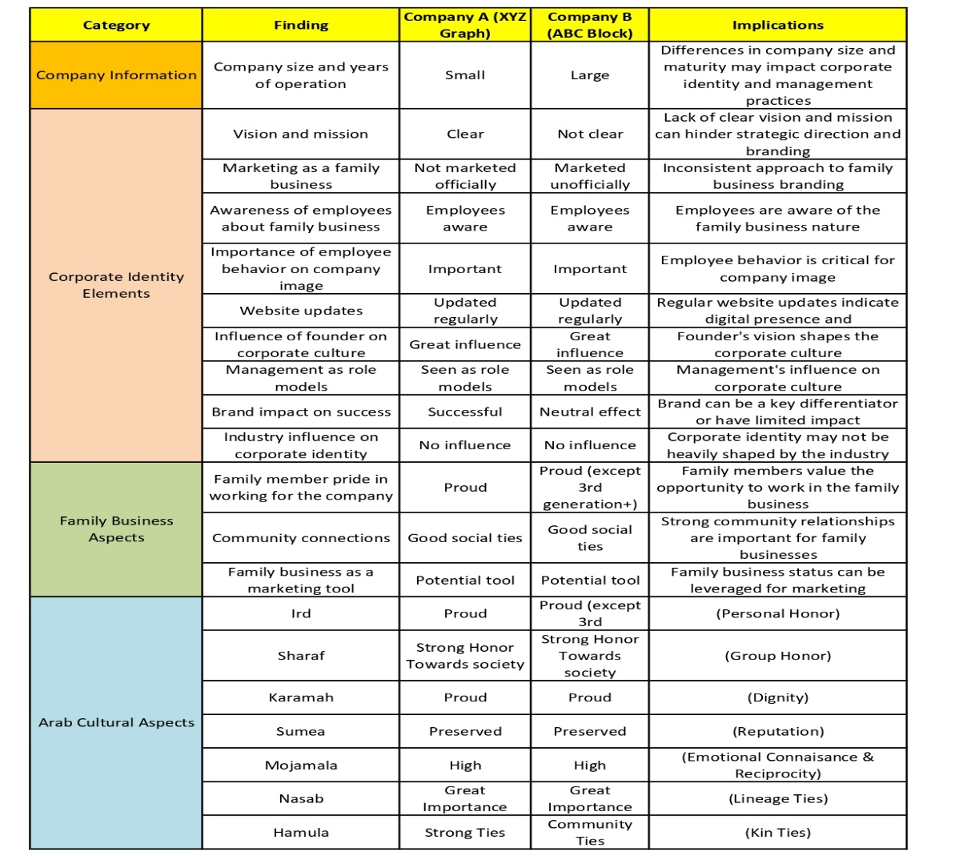
Table 1: Namus Corporate Family Identity in Bahrain

4. 4. The Theoretical Framework & Namus Definition

Based on the above discussion, we can recommend a theoretical framework to explain the Namus construct and provide a corresponding definition to accompany that model.
Namus is the unique family identity that integrates personal (‘Ird) and family (Sharaf) honor and essentializes the dignity of family members and kin (Karamah). Family reputation (Sumea) is preserved in society, while reciprocity and emotional connaissance (Mojamala) are enhanced within Extended (Hamula) and Blood (Nasab) family members. Family members must contribute to the added value of the family name and unique family identity, and spread and preserve it in society.

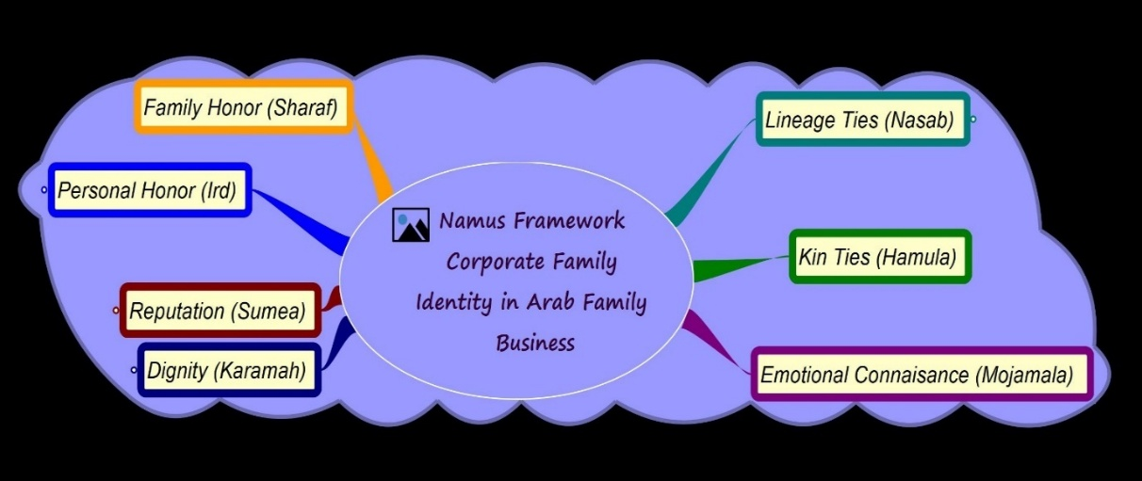
Figure 2: Namus – Corporate Family Identity Theoretical Framework

5. Conclusion and Implications
This paper reveals that Namus plays a major role in Arab family business corporate identity. The results provided an insight into the intense impact of cultural values related to business conduct, strategic choices, and relationships with stakeholders. The information is essential to the local and foreign companies in the Middle Eastern region that will help in improving their insights about these forces. In addition, it contributes to the literature by a. explaining the impact of cultural values on corporate identity formation, b. defining main mechanisms according to which Namus affects business operations, and c. giving valuable suggestions related to the management of family enterprises in the cultural context.

These cultural aspects, as highlighted by our study, have important practical implications of understanding and honoring in order to succeed as a leader, corporate manager and, corporate governance. It helps Arab family businesses incorporate their traditions with contemporary management styles to be sure that their survival into the future amid the pressure of globalization on the corporate world.
This is a combined method that highlights the multi-dimensional nature of Namus and makes it aligned with the more universal nature of the sociocultural and ethical responsibilities of corporate families. The nuanced interpretation (verstehen) of daily speech and activity invents of these cultural constructions is the result of our latent content analysis.

A close definition of these themes has shown us how the corporate culture is supported by individual strengths, and this has helped maintain a corporate family identity. These findings help highlight the need of modern firms to consider and integrate these cultural values in their systems of operation. The practice has contributed to a strong and coherent ethical setting, which enlightens the audience about the importance of cultural integration.
According to the research, Namus can influence the work of the company in the following ways:
The first considerations are processes of decision making, organizational culture and market positioning. Further, it gives possible future research directions with particular reference to (a) the MENA (Middle East and North Africa) setting, (b) Arabic culture, (c) Islam as a faith, and (d) Bedouin traditions. Such a candid promotion of the constructs of the proposed Arab Family Business Model (Namus, Diwan, Asabiyyah & Wasta) can make a difference to Arab family enterprises. Further research could be done to find out how family companies adjust their identity narratives to suit traditional values as well as the contemporary business norms and how globalization and technological advancements affect these narratives.
I would suggest that the research should be expanded by a larger sample of multi-sized family business in Bahrain and the study should include other countries family firms. This may either confirm the findings of this research or produce different results, which may motivate future research in family business to concentrate on theoretical research studies on the business family per se, unique paradoxes, and sound qualitative research methods.

References
Abbasi, A. Z., & Hollman, K. W. (2020). The power of the name: Family identity and brand equity in the Middle East. Journal of Islamic Marketing, 11(3), 597-614.
Abu-Lughod, L. (1986). Veiled sentiments: Honor and poetry in a Bedouin society. University of California Press.
Al-Alawi, A. I., & Fermanis, P. (2014). Succession planning in family businesses: A study of Bahraini firms. Journal of Small Business and Enterprise Development, 21(4), 668-686.
Ali, M. B. (2022). Delineating the Concept of Human Dignity in the Quran: Karamah al-insan as an Antidote to Religious Conflicts and Violence. Advances in Social Sciences Research Journal, 9(1), 220–235.
Alshibani, S. M., & Aljarodi, A. M. (2024). Family embeddedness and next generation aspirations to take over the family business: insights from the MENA region. International Journal of Emerging Markets.
Al-Ghamdi, S. M. (2018). The role of ethics in building corporate reputation: Evidence from Saudi Arabia. Journal of Business Ethics, 150(3), 801-815.
Al-Jafari, M. K., & Perry, A. C. (2011). Corporate branding and the Arab consumer: The mediating role of religiosity. Journal of Islamic Marketing, 2(1), 7–21.
Al-Khatib, J., Vollmers, S., & Liu, K. (2016). The role of cultural values in business ethics: The case of Arab countries. Journal of Business Ethics, 134(2), 329-342.
Al-Munajjed, M. (2000). Women in Saudi Arabia today. Palgrave Macmillan.
Al-Serhan, B. A. (2010). Islamic branding and marketing: Creating a global brand faith. Edward Elgar Publishing.
Blombäck, A. (2009). Family business: A secondary brand in corporate brand management. CeFEO Working Paper 2009:1
Balmer, J. M. (2001). Corporate identity, corporate branding, and corporate marketing- Seeing through the fog. European journal of marketing, 35(3/4), 248-291.
Balmer, J. M. (2017). Corporate brand management and strategic corporate brand orientation. Journal of Brand Management, 24(3), 193-194.
Basco, R. (2017). Epilogue: The multiple embeddedness of family firms in the Arab world. Family Businesses in the Arab World: Governance, Strategy, and Financing, 247–256.
Basly, S. (2017). Family businesses in the Arab world. Cham: Springer.
Baxter, D. (2007). Honor Thy Sister: Selfhood, Gender, and Agency in Palestinian Culture. Anthropological Quarterly, 80(3): 737–775.
Berger P. L., & Luckmann, T. (1966). The social construction of reality. A Treatise in the Sociology of Knowledge. Doubleday: New York.
Berger, R., Silbiger, A., Herstein, R., & Barnes, B. R. (2015). Analyzing business-to-business relationships in an Arab context. Journal of World Business, 50(3), 454-464.
Bettinelli, C., Lissana, E., Bergamaschi, M., & De Massis, A. (2022). Identity in family firms: toward an integrative understanding. Family Business Review, 35(4), 383-414.
Bourdieu, P. (1977). Outline of a theory of practice. Cambridge University Press. Bromley, D. B. (2001). Reputation, image, and corporate identity. Corporate Communications: An International Journal, 6(1), 24–31.
Cetinkaya, H. (2024). Re-theorising namûs beyond ‘honour’: self-making, feminist agency and global epistemic justice. Feminist Theory.
Chua, J. H., Chrisman, J. J., & Sharma, P. (1999). Defining the family business by behavior. Entrepreneurship theory and practice, 23(4), 19–39.
Craig, J. B., Dibrell, C., & Davis, P. S. (2008). Leveraging family‐based brand identity to enhance firm competitiveness and performance in family businesses. Journal of Small Business Management, 46(3), 351–371.
Creswell, J. W. (2014). Research Design: Qualitative, Quantitative and Mixed Methods Approaches (4th ed.). London: Sage Publications Ltd.
Creswell, J. W., Shope, R., Plano Clark, V. L., & Green, D. O. (2006). How interpretive qualitative research extends mixed methods research. Research in the Schools, 13(1), 1-11.
Creswell, J. W., & Plano Clark, V. L. (2011). Designing and Conducting Mixed Methods Research (2nd ed.). London: Sage Publications Ltd.
Creswell, J. W., & Creswell, J. D. (2017). Research design: Qualitative, quantitative, and mixed methods approach. Sage Publications.
Cunningham, R. B., & Sarayrah, Y. K. (1993). Wasta: The hidden force in Middle Eastern society. Praeger Publishers.
Darwish, S. (2020). Social Networks, Social Influence, and Socio-Structural Factors Associated with Arab Adults’ Tobacco Use in the US. University of Massachusetts Boston.
Dodd, P. C. (1973). Family honor and the forces of change in Arab Society1. International Journal of Middle East Studies, 4(1), 40–54.
Dutton, J. E., & Dukerich, J. M. (1991). Keeping an eye on the mirror: The role of organizational identity and image in organizational adaptation. Academy of Management Journal, 34(3), 517-554.
Dwyer, D. H. (1978). Images of East African women in Kiswahili prose fiction. Ba Shiru, 9(2), 47-57.
Elo, S., & Kyngäs, H. (2008). The qualitative content analysis process. Journal of Advanced Nursing, 62(1), 107-115.
El-Sayed, M., & Craig, J. (2017). Family business branding: Exploring the role of family values and identity. Journal of Family Business Strategy, 8(1), 14–25.
Esposito, J. L. (2002). What everyone needs to know about Islam. Oxford University Press
Farah, B., Elias, R., Aguilera, R., & Abi Saad, E. (2021). Corporate governance in the Middle East and North Africa: A systematic review of current trends and opportunities for future research. Corporate Governance: An International Review, 29(6), 630-660.
Faraj, S. F. (2022). Boys Don't Cry: A study on how young men in Amman define honour: Master's Thesis, Stockholm University.
Farouk Abdel Al, S., Jabeen, F., & Katsioloudes, M. (2017). SMEs Capital Structure Decisions and Success Determinants: Empirical Evidence from the UAE. Journal of Accounting, Ethics and Public Policy, 18(2)
Flyvbjerg, B. (2006). Five misunderstandings about case-study research. Qualitative Inquiry, 12(2), 219-245.
Fukuyama, F. (1995). Trust: The social virtues and the creation of prosperity. Free Press.
Gerring, J. (2007). Case study research: ² What it is, what it does—the. SAGE handbook of case-based methods (pp. 1–22). SAGE Publications.
Goffman, E. (1967). Interaction ritual: Essays on face-to-face behavior. Anchor Books.
Granovetter, M. S. (1985). Economic action and social structure: The problem of embeddedness. American Journal of Sociology, 91(3), 481-510.
Hassan, S., & Khalifa, A. (2021). Trust and reputation in business-to-business relationships in the UAE. International Journal of Emerging Markets, 16(4), 687–705.
Hosmer, L. T. (1995). Trust: The connecting link between organizational theory and philosophical ethics. Academy of Management Review, 20(2), 379-403.
Hsieh, H. F., & Shannon, S. E. (2005). Three approaches to qualitative content analysis. Qualitative health research, 15(9), 1277-1288.
Jamal, A., & Al-Khatib, J. A. (2003). Determinants of customer satisfaction in the context of Saudi Arabia. Journal of International Consumer Marketing, 15(4), 5-25.
Jamali, D., Hallal, M., & Abdallah, H. (2010). Corporate governance and corporate social responsibility: evidence from the healthcare sector. Corporate Governance: The international journal of business in society, 10(5), 590-602.
Kabbach, A. (2011). The influence of tribal culture on business practices in the Middle East. Thunderb’’Ird International Business Review, 53(6), 711–723.
Kanoo, K.M. (2011). An insight into family business enterprises in Bahrain. Bahrain Family Business Association, Kingdom of Bahrain.
Khanna, T., & Palepu, K. G. (2010). Emerging giants. Rivals from developing countries are invading your turf. How will you fight back, 35.
Köllner, T. (2022). Family firms and business families: A field for anthropological research. Anthropology Today, 38(6), 8-10
Krappe, A., Goutas, L., & von Schlippe, A. (2011). The “family business brand”: An enquiry into the construction of the image of family businesses. Journal of Family Business Management, 1(1), 37-46.
Krippendorff, K. (2004). Content analysis: An introduction to its methodology (2nd edition). SAGE Publications.
Kropf, A., & Newbury-Smith, T. C. (2016). Wasta as a form of social capital? An institutional perspective. In The political economy of Wasta: Use and abuse of social capital networking (pp. 3-21). Cham: Springer International Publishing.
Krueger, N., Bogers, M. L., Labaki, R., & Basco, R. (2021). Advancing family business science through context theorizing: The case of the Arab world. Journal of Family Business Strategy, 12(1), 100377.
Kuran, T. (2004). Islam and underdevelopment: An old puzzle revisited. Journal of Economic Perspectives, 18(4), 141–164.
Lancaster, W. O. (1997). The Rwala Bedouin today. Waveland Press.
Lincoln, Y. S., & Guba, E. G. (1985). Naturalistic Inquiry. SAGE Publications.
Meeker, M. E. (1976). Meaning and Society in the Near East: Examples from the Black Sea Turks and the Levantine Arabs (I). International Journal of Middle East Studies, 7(2), 243-270.
Metcalfe, B. D. (2007). The cultural context of leadership in the Middle East. Leadership & Organization Development Journal, 28(7), 670–687.
Mondey, A., & Beeri, I. (2023). The competing impact of network politics and Hamula (clan) politics on perceived network performance: the case of minority networks. Local Government Studies, 1–26.
Mudin, I. (2024). Crossroads of civilizations: the social and cultural landscape of pre-Islamic arab. Journal of Social Science, 1(4), 36–47.
Naber, N. (2005). Arab American femininities: Beyond victimhood and silence. Signs: Journal of Women in Culture and Society, 30(4), 2155–2181.
Palaiologos, G, T. (2017). Theorising on Arab Family Businesses. In Basli, S. Family Businesses in the Arab World: Governance, Strategy, and Financing (pp. 23-40). Springer International Publishing.
Palaiologos, G., & Köllner, T. (2025). Theorising on the Latino Family Business Simpatia (Connectedness), Familismo (Knowledge Reservoir), Fama (Organisational Identity), and Solidaridad (Social Embeddedness) Contexts. Journal of Enterprising Culture, 1-29.
Patai, R. (1983). The Arab mind. Charles Scribner's Sons.
Patton, M. Q. (2015). Qualitative research & evaluation methods: Integrating theory and practice. SAGE Publications.
Purfield, M., Finger, M.H., Ongley, M.K., Baduel, M.B., Castellanos, C., Pierre, M.G., Stepanyan, V., & Roos, M.E. (2018). Opportunity for All: Promoting Growth and Inclusiveness in the Middle East and North Africa. International Monetary Fund.
Radu-Lefebvre, M., Davis, J. H., & Gartner, W. B. (2024). Legacy in family business: A systematic literature review and future research agenda. Family Business Review, 37(1), 18-59.
Ramadani, V., Hisrich, R. D., & Gerguri-Rashiti, S. (2015). Family firms and entrepreneurship in transition economies: Opportunities and challenges. World Review of Entrepreneurship, Management and Sustainable Development, 11(1), 1-17.
Ratten, V. (2023). A new definition of family business. Journal of Family Business Management, 13(3), 545–545.
Ratten, V., Chrisman, J. J., Mustafa, M., Sciascia, S., Seaman, C., Discua Cruz, A., & Feranita, F. (2024). Learning from family business researchers. Journal of Family Business Management, 14(4), 735-747.
Rautiainen, M., Rosa, P., Pihkala, T., Parada, M.J. and Discua Cruz, A. (2019). (Eds), The Family Business Group Phenomenon: Emergence and Complexities, Palgrave Macmillan, doi: 10.1007/ 978-3-319-98542-8.
Redding, S. G. (2005). The thicket of kinship: Implications for business organisation. In M. Warner (Ed.), Regional encyclopedia of business and management: Management in Asia Pacific (pp. 613–621). Thomson Learning.
Rice, J., Raziq, M. M., & Fotiadis, A. (2024). Family business in the Arabian Gulf region. Journal of Family Business Management, 14(4), 775-780.
Samara, G. (2021). Family businesses in the Arab Middle East: what do we know and where should we go? Journal of Family Business Strategy, 12(3), 100359.
Schneider, J. (2017). Dignity and human rights. In J. Fieser & N. Fotion (Eds.), The Routledge handbook of business ethics (pp. 191-202). Routledge.
Schwandt, T. A. (2007). The SAGE dictionary of qualitative inquiry. SAGE Publications.
Sidani, Y. M., & Thornberry, J. (2013). Developing Arab management research: Contextual and theoretical perspectives. Academy of Management Perspectives, 27(4), 342-358.
Stake, R. E. (1995). The art of case study research. SAGE Publications.
Stewart, F. H. (1994). Honor. University of Chicago Press.
Tagiuri, R., & Davis, J. (1996). Bivalent attributes of the family firm. Family business review, 9(2), 199-208.
Thompson, E. P. (2010). The moral economy of the English crowd in the eighteenth century. In Customs in common (pp. 185–258). The New Press.
Tsai, S. P. (2008). Corporate marketing management and corporate identity building. Marketing Intelligence & Planning, 26(6), 621–633.
Velez-Calle, A., Robledo-Ardila, C., & Rodriguez-Rios, J. D. (2015). On the influence of interpersonal relations on business practices in Latin America: A comparison with the Chinese guanxi and the Arab wasta. Thunderb’’Ird International Business Review, 57(4), 281-293.
Weir, D., Sultan, N., & Bunt, S. V. D. (2019). Doing business in the Arab world: Unlocking the potential of wasta. Globalization and Development: Entrepreneurship, Innovation, Business and Policy Insights from Asia and Africa, 323–341.
Whetten, D. A. (2002). Modelling-as-theorizing: A systematic methodology for theory development. In Essential skills for management research (pp. 46–71). SAGE Publications Ltd.
Whetten, D., Foreman, P., & Dyer, W. G. (2014). Organizational identity and family business. The SAGE handbook of family business, 480–497.
Yasin, S. (1985). The Arab family and the social crisis. In H. Beblawi & G. Luciani (Eds.), The Arab state (pp. 185–201). University of California Press.
Yin, R. K. (2018). Case study research and applications (6th ed.). SAGE Publications.
Yousif, A. M., & Abuamsha, F. H. (2019). Social capital and firm performance: The mediating role of knowledge sharing in Jordanian SMEs. Journal of Knowledge Management, 23(4), 711–731.
Zahra, S. A. (2005). Governance and entrepreneurship in the family firm. Family Business Review, 18(3), 163–171.
Zellweger, T. M., Eddleston, K. A., & Kellermanns, F. W. (2010). Exploring the concept of familiness: Introducing family firm identity. Journal of family business strategy, 1(1), 54-63.
Zellweger, T. M., Kellermanns, F. W., Eddleston, K. A., & Memili, E. (2012). Building a family firm image: How family firms capitalize on family ties. Journal of Family Business Strategy, 3(4), 239-250.

