Research on short video marketing Strategy of tourist attractions

Nuo Shi *
PresidentUniversity
shinuo0815@gmail.com

Abstract
Primary Objectives: At present, the increasingly mature new media technology provides more convenient and diversified channels for the communication of tourist attractions, and the transmission of tourist attractions is gradually transitioning from traditional media to new media. Background Problems: As a new communication tool, a short video has become an essential means of publicity and marketing because of its duo-cross solid attributes, short duration, and low technical threshold. Based on this background, this article mainly aims at the new media environment represented by the rill platform of short video mode to observe and study tourism scenic area marketing. Novelty: This paper analyzes the marketing status of short tourism videos on web media, considering the perspectives of both tourism web media accounts and audiences. It draws broad conclusions by analyzing the behaviours of web media accounts and observing audience reactions. The study focuses on various randomly selected travel content from the media. Research Methods: The paper adopts the case study method, with a few fan bases of official tourism scenic area short video account as the main case, analysis of its promoting in the trill, analysis of the advantages and existing problems, and the optimization advice For example: focus on short video marketing content, integrate multiple marketing models and establish or cooperate with a professional marketing team. Finding/Results: According to QuestMobile's data, TikTok has 421 million active users and an average daily usage time of 104 minutes in 2022. TikTok's central station has 675 million monthly active users, a 7.2% increase, making it a leading competitor in the short video industry. Conclusion: This study suggests the current tourism scenic spot marketing to provide reference significance.

Keywords: tourist attractions, short video, tourism marketing, marketing strategy

1. Introduction
With the continuous development of science and technology, we have long been used to the various Internet applications in modern life. The Internet is slowly filling every aspect of our lives and constantly changing how we think and behave. The change in the communication environment promotes continuously upgrading Internet media (Yogesh et al., 2021). Short videos have emerged and developed rapidly in recent years, relying on social network platforms. With their advantages of volume, precision, efficient communication and convenient reception, they meet people's needs of reading and sharing information in fragmented time. It has quickly become one of the essential contents and means of information exchange in People's Daily life.

After the current short video platform has become the gathering place of traffic, more and more enterprises realize that short video marketing can bring more opportunities for the development of enterprises, so they begin to gradually carry out a series of marketing activities on the short video platform. Like other types of short videos, the group of short videos in tourist attractions is expanding. Compared with the traditional tourism e-commerce platform, short videos reach a larger audience, and the big intelligent data of the background of the short video platform can push short tourism videos to the matched target groups more accurately. Watching official promotional short videos can positively impact potential consumers' impressions of tourist destinations (Shani et al., 2010). From the marketing perspective, this paper studied and analyzed how the audience favours short videos of scenic tourism spots, observed and analyzed the marketing status and strategies, found the advantages and disadvantages behind the data, and further put forward suggestions for the future marketing of short tourism videos.
.

Literature review

Tourism marketing plays a crucial role in overall marketing and is essential for developing the tourism industry. It involves applying marketing concepts to the tourism sector, understanding traveller needs, identifying target markets, and designing appropriate products and services to meet market demands. Research in this area has also grown as the tourism market continues to expand. For example, studies have explored topics such as service commitment, the impact of virtual reality technology on tourism marketing, and the potential of combining gaming with tourism marketing(Yu et al., 2015). Traditional marketing for tourist attractions typically involves using platforms like TV, magazines, and advertisements to promote the brand and disseminate product information. In contrast, self-media marketing requires attractions to engage with their audience more personally to build trust. While research on tourist attraction marketing is limited compared to general tourism marketing studies, some models have been proposed for optimizing attraction-specific strategies based on factors like positioning within the market environment or utilizing various channels such as online collaboration or green initiatives.
There is yet to be a unified conclusion on the concept of short video marketing, and different scholars have provided varying definitions. Some argue that short video marketing involves using brief videos to promote and sell products on a platform. In contrast, others emphasize its unique ability to redefine the rules of video distribution(Geng X. et al., 2021). Short videos possess several characteristics that offer numerous advantages for marketing (Bhardwaj J et al., 2020). They can engage vision and hearing, enhance authenticity and interactivity, target audiences more accurately based on algorithms, spread quickly due to their easy understanding, contain high information density, and allow for emotional connection and direct communication with the audience(Sun X., 2020). Short video marketing has its unique characteristics, immediacy, splicing capabilities, and simplified technology, redefining video dissemination's language rules. (Wang Xiaohong et al., 2015).
The threshold for short videos is low, yet they contain a wealth of information and can be transmitted quickly. Additionally, they can fully engage consumers' senses in a virtual environment (A Krmer, S.etal.,2016). Short videos are played on various new media platforms, with no strict regulations on length. They are typically less than 5 minutes long and cover personal life, travel sharing, skill sharing, humour, fashion, social hotspots, news, and advertising creativity. Short videos have become the third most popular form of communication after text and images. Short video marketing has unique characteristics, immediacy, splicing capabilities, and simplified technology, which redefine the language rules of video dissemination (Wang Xiaohong, 2015). With the popularity of mobile interneInternettwork development, short videos have gained massive traffic due to their low production cost and fast dissemination. The fastest growing platform for short videos is Tiktok."

3. Research Method
This study used case analysis. Tourism web media on Douyin's short video platform was mainly selected as the case for analysis because compared with other Chinese short video platforms, Douyin's short video platform is a short video platform with many daily active users. Through the case analysis of the marketing communication practice of tourism, we media on the Douyin(TikTok) platform, and the marketing mode adopted by tourist attractions on a short video platform is summarised. This paper undertakes a comprehensive study of the marketing strategy of short video accounts of tourist attractions. Drawing from established marketing theory, the marketing problem of a short travel video account is dissected into three variables: account, marketing mode, and marketing environment. Each variable is then meticulously coded into three crucial factors through careful observation and summary. The culmination of this research is a detailed analysis of the positive and negative factors influencing the short video marketing strategy of tourist attractions, accompanied by pertinent suggestions for improvement. The first aspect we delve into is the account mode. This model is user-oriented and thrives on platform dependence, fostering a dynamic multi-party collaborative environment. This collaboration is further enriched by government-enterprise cooperation. The account's content is a blend of works primarily produced by the account, encompassing scenic spots, guides, and daily sharing. The scenic ticket sales business account contributes to the other part, featuring contact information, a purchase page, an attraction introduction, and tourist reviews. Next is the current marketing model of short videos in tourist attractions. In recent years, as new models in the field of short video have been continuously explored, iResearch Consulting's 2018 Q2 report shows six video advertising models with low to high investment costs: hard advertising, content placement, customized content, network red activities, account operation, and cross-platform integration. Specifically, the market model of official certification numbers in the tourism industry includes the subdivision marketing model, target marketing model, positioning marketing model and the use of digital technology to promote the management of goods and services. However, the current market awareness and environment have shown a positive trend. The short video of tourist attractions has played a positive role in promoting the development of technology and the popularity of social networks brought by the intelligent big data background environment.

4. Result and Discussion
4.1 Comparison between Douyin and other short video platforms
Whether in China or the whole world, the field of short video platforms has been dominated by TikTok and the international version of TikTok. According to the report, 19.4% of people aged 18 and over globally use TikTok. If we delete people in this age group who live in China (where ByteDance offers a standalone app called TikTok in place) and India (where TikTok is still blocked), the platform's reach increases to 31.2 per cent. (DataReportal)
Furthermore, Tiktok's parent company, Bytedance, began to enter the short video field in 2016, respectively launching Tiktok, For Fashion Young People UGC (User-generatedContent), volcano UGC (User-generatedContent), watermelon PGC (professional-generated content), Bytedance's short video platform has captured most of the short video market in China. On January 8, 2020, the volcano video and Tiktok officially announced the brand integration and upgrading, and the volcano video was renamed the Tiktok Volcano version. According to the short video industry user data released by QuestMobile, the number of daily active users of TikTok in 2022 is as high as 421 million, and the average daily use time of users is 104 minutes. The number of monthly active users of Tiktok central station is 675 million, an increase of 7.2%, and the competitiveness of short video service is in the leading position in the industry. Other short video platforms can not surpass the second largest Kuaishou platform: daily active users are 347 million, monthly active users are 393 million, a decrease of 7.5%.
4.2 Account analysis of tourist attractions on the Douyin short video platform
This paper analyses the marketing status of the short tourism video we media from the perspectives of tourism web media accounts and audiences. It draws a broad conclusion by analyzing the behaviours of web media accounts and observing audiences' reactions. This study trilled on various travel randomly selected from the media. Therefore, we found that after finishing trill platforms tourism since the media is very much in addition to the official certification of scenic spots in accounts and tourist class personal accounts. Though considering the content of individual accounts in tourist groups, content is more cluttered, so choose a scenic spot in screening companies' certified accounts. I selected six with a particular scale and popularity as the specific research objects and made a table for more intuitive understanding.
Table 1Travel short video account
Account Name | Number of followers of the account
Nanxun Ancient Town Scenic Spot | 316.9w
Henan Laojunshan Scenic Area | 118.4w
Fujian Xiaoxia Tourism Zone | 90w
Wuzhen Tourist attraction | 58.2w
Shennongjia Scenic Spot | 28.3w
The ancient City of Kashgar Scenic Area | 22.2w

4.3 Account Home Page Display
On the page display on the home page of the account of the tourist attraction, first of all, the profile picture of the account is the logo or scenery picture of the tourist attraction, which will make people notice it at a glance and leave a unique impression and deepen people's memory. The account names are official, allowing people to notice directly. Then, on the home page, the location is a brief introduction to the scenic spot or the slogan or publicity of the scenic spot. Short links, such as contact number, view address, and online booking, are added below. Users can directly click for consultation, and communication is very convenient. The content displayed in the middle of the account page mainly comprises works and merchants.
Figure 1Home page of a short video account of tourist attraction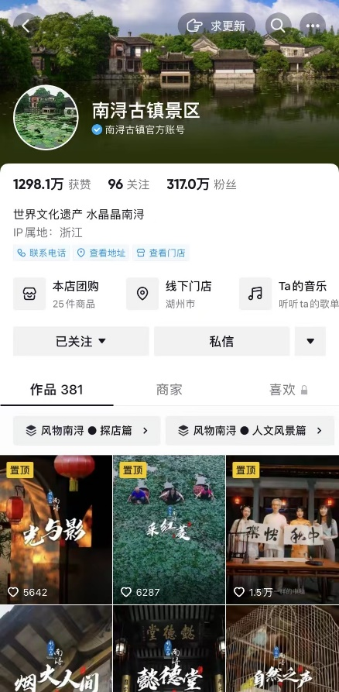
  - Analysis of Account Works

- Number of works published
From the point of view of the number of works, most education and training institutions release many works with high frequency and long duration. Therefore, many works with high frequency and long time indicate that Douyin's short video marketing is an essential marketing means for these scenic spots, which must be constantly updated and maintained to get the audience's attention.

Table 2Number of tourism short video account works
Account Name | Account Name Number of works
Nanxun Ancient Town Scenic Spot | 380
Henan Laojunshan Scenic Area | 950
Fujian Xiaoxia Tourism Zone | 310
Wuzhen Tourist attraction | 640
Shennongjia Scenic Spot | 471
The ancient City of Kashgar Scenic Area | 584

- Work content
For the content analysis of tourism short video accounts, the author classifies the content after browsing the six representative short video works of tourism scenic spot accounts on Douyin. As a result, We can divide the short video content display into four categories: scenic spots, tourism guides, daily sharing, and live playback, and the proportion of each kind of short video is calculated.

Table 3 Content statistics of tourism short video accounts
Account Name | Scenic | Tourism Guide | Daily share | live and playback
Nanxun Ancient Town Scenic Spot | 59% | 25% | 15% | 1%
Henan Laojunshan Scenic Area | 85% | 5% | 10% | 0%
Fujian Xiaoxia Tourism Zone | 85% | 5% | 10% | 0%
Wuzhen Tourist attraction | 89% | 5% | 5% | 1%
Shennongjia Scenic Spot | 80% | 15% | 5% | 0%
The ancient City of Kashgar Scenic Area | 50% | 40% | 10% | 0%

The account content statistics show that most of the contents of the short video account of tourist scenic spots are mainly scenic spots that offer the unique and beautiful scenery of their respective scenic spots. The short video indicates that displaying scenic spots is the leading way to attract fans for tourism marketing. The tourism guide also occupies a part of the content of the work, and the cultural scenic spot of Kashgar Ancient City, which mainly focuses on tourism projects, is the leading marketing content. In addition, the accounts of Nanxun Ancient Town Scenic Spot and Wuzhen Tourist Scenic Spot also added live playback of daily broadcast activities to the works. The short video also shows the scenic spot's beautiful scenery and play items through the first live broadcast perspective, which many fans also loved. In addition, regarding the layout of works, "works collection" and "top" are used to optimize the order of works display to attract more fans with the best works.
4.5 Account Merchant Analysis
The business part of the home page of the short video account of tourist attractions differs from the ordinary short video account. In the business section, the account of the scenic tourist spot shows the offline stores (the name and location address of the shoppable stores in the scenic spot or scenic spot accommodation, restaurants, exhibitions and other scenic spots, as well as the labels of special services such as 5A scenic spot and World Cultural heritage). After clicking the displayed store, we can see the more detailed store address, contact information and business hours. Then, the group purchased activities from the stores, such as scenic spot tickets, scenic spot restaurant packages, and hotel two-day and one-night packages. Offers can be purchased and booked directly. Then, there are environmental pictures of scenic spots and play projects and a tourist evaluation.

Through the observation and analysis of the business part of the homepage of the short video account of tourist attractions, it is clear that the business part is the function transfer of the third platform of traditional tourism e-commerce. People can directly make travel reservations in the business part, which is the primary way to realize the marketing of the short video platform of tourism。

Figure 2:Short video account home page merchants display
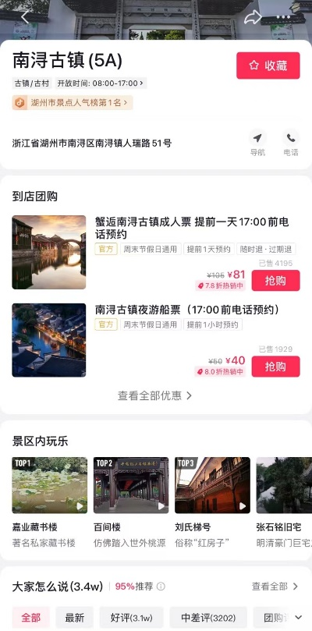

4.6 Marketing strategy analysis of a short video account of a tourist attraction

- Tourism scenic spot short video account marketing mode
There are three main cooperation models for brands in short video marketing: cooperation between brands and Internet celebrities/KOLs, cooperation between advertisers and MCNs, and cooperation between brands and platforms.
With the popularity of short video marketing, more enterprises are constantly exploring this new mode. Research Consulting will consider the video marketing mode according to the cost of investment, from low to high, which can be divided into six modes: hard advertising, content implantation, content customization, Internet celebrity activities, account operation, and cross-platform integration.

After observing and researching the current short video accounts of tourist attractions, this study found that these accounts' marketing cooperation and marketing modes are relatively simple. The marketing cooperation mode mainly promotes tourist attractions by launching short video competitions with scenic spots and cooperating with Internet celebrities. The marketing mode mainly focuses on account operation, content implantation of scenic spots and cultural scenery, and content customization based on scenic spot play strategy.

5. Conclusion and Implications
Problems existing in short video account marketing of tourist attractions are poor content marketing quality, single marketing model, and lack of fan operations. Through the classification and content observation of works, this study found that the content of most works of the account is relatively simple and needs more creativity and highlights. Although the number of works is large, the published content could be more organized. The poor quality of work will not attract more traffic to achieve the transformation of benefits. The short video accounts with the official certification of tourist attractions extracted through research and analysis have few marketing activities except account operation, single marketing mode and few ways to attract traffic/attention. After comparing the operation channels of other beauty and entertainment short video accounts, it is found that although tourist scenic spot accounts have hundreds of thousands or even millions of fans and attention, they rarely interact with fans and lack the establishment of fan groups and the way to transform fans into WeChat groups, public accounts, small programs and other private domains through short video platforms. Suggestions on marketing strategies for short video accounts of tourist attractions are: focus on short video marketing content, integrate multiple marketing models, and establish or work with a professional marketing team. To increase the quality of works, whether video or comment, we should start with consumer psychology, strengthen contact and connection with users, make more original initiatives, and eliminate the monotone and substandard plot of rich works. Short video platforms such as Kuaishou, Watermelon Video, Volcano Video and Douyin have some overlap of users, but the positioning and general audience of each platform are different. Integrated marketing can be carried out on various platforms according to the characteristics of other platforms. In short video platforms, only by continuously exporting high-quality content can the audience's trust be improved and high traffic be maintained. The quality of short videos in tourist attractions could be better. We want to develop short video marketing continuously. In that case, we should constantly improve our professionalism, establish a team to manage multiple links such as creativity, shooting, post-production and follow-up management of fans, or cooperate with a professional team to continuously optimize the output content.

References
A Krmer, S., Bhrs.(2016). How Do Consumers Evaluate Explainer Videos? An Empirical Study on theEffectiveness and Efficiency of Different Explainer Video Formats[J]. Journal of Education& Learning
Geng X, He J. (2021). Research on Short Video Marketing Path of Traditional Handicrafts[C]., 6th International Conference on Economics, Management, Law and Education (EMLE 2020). Atlantis Press, pp.247-250.
Huang Yuchih. (2018). Backman Kenneth Frank, Backman Sheila[J]., ChangLan Lan, Exploring the Implications of Virtual Reality Technology in Tourism Marketing: An Integrated Research Framework[J], DO:https://doi.org/10.1002/jtr.2038.
Bhardwaj J, Sharma A K.(2020) How Video Marketing in E-Commerce Can Boost Sales[J]. IME Journal, pp.90-96.
Wang Xiaohong, Bao Yuanyuan, Lv Qiang. (2015). Development Status and Trend Observation of Mobile Short Video[J]. China Editor, pp. 7-12.

